朝陽科技大學新進教職員工報到須知
115/1/5版
Chaoyang University of Technology
Orientation Guide for New Faculty and Staff
◎各類人員均應於聘期或聘僱起始日「前」完成報到手續。（教師8月1日起聘者，請於7月20日前辦理完成；2月1日起聘者，請於1月20日前辦理完成）
All personnel are required to complete the registration procedures before the commencement of their contract or employment period. (For teachers hired from August 1, please complete the process by July 20, and for those hired from February 1, please complete the process by January 20.)
◎新進人員資料繳交如表所列，表單由人資處代為收件後統一轉發，填表如有未明之處，請依表列直接洽詢業管單位。
Below table shows items of document that new recruits are required to submit to the Office of Human Resources. If you have any questions preparing documents or filling out the forms, you may contact the corresponding units at the extension listed below.
◎提醒：各表件請電腦繕打，A4，單面，列（影）印。
Reminder: Please type your information on the PC, single-sided A4 paper, and submit in printed format.
類別  Cat. | 表件編號  Form No. | 表格名稱  Items | 說 明  Description | 適用對象  Applicable to  A.專任教師  Full-time Faculty  B.專任職員  Full-time Staff  C.專案教師  Project Faculty  D.幼兒教師  Kindergarten Teacher  E.約聘雇員  Contract Employee | 承辦/分機  Contact No.
個人  報到  Report Duty | - | 報到單及人事資料繳交紀錄表  Registration Form and Check List for Faculty and Staff | 1.本人親自報到【行政大樓4樓人資處】。  Approach the Office of Human Resources in person (4F, Admin Bldg.)  2.本單請置於本次繳交資料首頁  Place this page at the front of the submitted information. | 全適用  All | 教師:張宜男/3024  職工:張心綸/3027  Ms. Chang Yi-nan at ext. 3024 (Faculty)  Ms. Chang Hsin-lun at ext. 3027 (Staff)
個人  報到  Report Duty | 1 | 新進人員個資告知聲明  Personal Data Collection Statement for New Joiners | 佐證文件(例:身分證、教師證書、畢業證書、退伍令等)均應繳送正本及影本(A4，單面)，正本驗畢歸還。  Supporting documents (e.g., ID card, teaching certificate, diploma, discharge certificate, etc.) should be submitted in both original and photocopy (single-sided A4). The original documents will be returned after verification. | 全適用  All
個人  報到  Report Duty | 2 | 教職員工履歷表  Resume for Faculty and Staff |  | 全適用  All
個人  報到  Report Duty | 3 | 教職員工履歷表_附件封面暨檢核單  Attachment Cover and Check Sheet for Faculty and Staff Resume |  | 全適用  All
個人  報到  Report Duty | 4 | 職員工具結書  Staff Declaration |  | B、E
薪資  保險  Salary & Insurance | 5 | 薪資所得受領人扶養親屬申報表  Tax Deduction Application for Dependent Family Members | 依所得稅法規定辦理。  Process per the Income Tax Act. | 全適用  All | 敘薪.公.健:  蘇郁卿/3026  勞.健:張心綸/3027
薪資  保險  儲金  Salary & Insurance & Retirement Fund | - | 公務人員保險/  勞工保險  Civil Servant Insurance/  Labor Insurance | 1.依到職日加保。  Coverage begins on the date of employment.  2.如需勞工退休金自願提繳，請至勞工局下載「勞工退休金提繳申報表」後送至人資處憑辦。  If you wish to voluntarily contribute to the labor retirement pension, please download the 'Labor Retirement Pension Contribution Declaration Form' from the website of Bureau of Labor Insurance and submit it, along with supporting documents, to the Office of Human Resources. | 依身分別主動辦理  Faculty and staff should take initiative to process application per their respective identity. | 敘薪.公.健.儲金:  蘇郁卿/3026  勞.健:張心綸/3027  Ms. Su Yu-ching at ext. 3026 (Salary/Civil Servant/Health Insurance/Retirement Fund)  Ms. Chang Hsin-lun at 3027 (Labor/Health Insurance)
薪資  保險  儲金  Salary & Insurance & Retirement Fund | 6 | 健保投保申報表  National Health Insurance Enrollment Application | 1.請確認到職當日前投保單位已轉出。  Please confirm that the previous insurance coverage has been terminated by the ex-employer before the date of employment with CYUT.  2.眷屬隨同加保者，請一併填寫並檢附該位身分關係證明（如戶口名薄）。  For family members applying for coverage together, please also complete the form and attach proof of their relationship (such as a household registration booklet). | 全適用  All
薪資  保險  儲金  Salary & Insurance & Retirement Fund | 7 | 曾任軍公教人員 離職、退休、退伍調查表  Resignation / Retirement / Discharge Survey Form for Former Military, Public Service, and Education Personnel | 本表將做為本校對私校退撫會提撥儲金及相關運用，請詳實填寫。  This form will be used by our university to allocate funds and manage resources for the private school retirement fund. Please complete it accurately. | 全適用  All
團險  Group Insurance | 8 | 團保加保同意書  Consent Form of Group Insurance (Optional to join but the insurance company will review the physical condition and eligibility.) | 1.自由參加，但需經保險公司審查體況及投保資格) _填寫範本  Open to voluntary participation, subject to health assessment and eligibility review by the insurance company.  2.如眷屬欲隨同加保，加保者皆應繳交保險公司所提之醫療個資利用同意書及健康聲明書（此為圖檔，請手寫）。  If family members wish to join, all additional insured individuals are required to submit the medical data consent form and health declaration form provided by the insurance company (pls. print out the form and hand written on it). | 依需求申請  若無則免  On your needs | 李雨蒨/3028  Ms. Li Yu-chien at ext. 3028
身分  識別  Identity | - | 教職員工證  Employee Card | 免申請主動辦理，本校為悠遊卡，含校園門禁及借書功能，人資處主動通知領取。  The card combines EasyCard, campus access control, and library borrowing functions. The Office of Human Resources will automatically issue the card and notify you for pick-up. | 全適用  All | 李雨蒨/3028  Ms. Li Yu-chien at ext. 3028
總務  事項  General Affairs | 9 | 教職員工建立薪資帳戶  Salary Account Information | 請先行剪貼存摺影本。  Cut and paste the passbook copy on the form.  註：每月10日給付當月薪資。  Note: Payday falls on 10th of each month. | 全適用  All | 出納組/6061  Bursary Section at ext. 6061
總務  事項  General Affairs | 10 | 汽機車停車證申請表  Parking Permit Application Form | 停車證需收費(由薪資扣減)。  Parking permit is subject to charges (deduct from salary). | 依需求申請  若無則免  On your needs | 事務組/6012  General Section at ext. 6012
總務  事項  General Affairs | - | 教師研究室分配  Research Room | 免申請，由保管組主動通知辧理。  The Property Services Section will notify you. | A | 保管組/6073  Property Services Section at ext. 6073

其他  Others | 附件1  Attachment 1 | 體檢報告  Medical Report | 1.應為近6個月內體健報告，請參閱附件1。  It should be a health report within the last 6 months. Refer to Attachment 1 for details.  2.特殊個資，請親自逕交環境安全衛生處。【行政大樓1樓A-102】。  The report contains sensitive personal data, please submit it to the Office of Environmental Safety and Health in person (A-102, 1F, Admin Bldg.). | 全適用  All | 環安處/6096  Office of Environmental Safety and Health at ext. 6069
其他  Others | 附件2  Attachment 2 | 電子郵件帳號  Email Account | 帳號：t+人事代碼@cyut.edu.tw  本校主動依聘期建立帳號，其餘事項請參閱附件2  Account: t+EmployeeNo.@cyut.edu.tw  The school creates an account automatically. Refer to Attachment 2 for details. | 全適用  All | 圖資處/3092  Office of Poding Memorial Library and Information Services at ext. 3092
＊學校總機：04-23323000 TEL: 04-23323000
＊人力資源處辦公室地點：行政大樓4樓A401.2
Office of Human Resources: A401.2, 4th Floor, Administration Building

朝陽科技大學 【教職員工】報到單及人事資料繳交紀錄表
Chaoyang University of Technology
Registration Form and Check List for Faculty and Staff
報到人簽名Applicant Signature：
報到日期： 年 月 日

Date of Registration: YY YY / MM / DD
編號  Entry | 資料名稱  Item | 繳交（人資處填寫）For HR Use
編號  Entry | 資料名稱  Item | 已繳 | 無資料 | 預計補件日（鉛筆填入）
1 | 新進人員個資告知聲明  Personal Data Collection Statement for New Joiners
2 | 教職員工履歷表  Resume for Faculty and Staff
3 | 教職員工履歷表_附件封面暨檢核單  Attachment Cover and Check Sheet for Faculty and Staff Resume
4 | 職員工具結書(限職工)  Staff Declaration (For non-teaching staff only)
5 | 薪資所得受領人扶養親屬申報表  Tax Deduction Application for Dependent Family Members
6 | 健保投保申報表  National Health Insurance Enrollment Application
7 | 曾任軍公教人員 離職、退休、退伍調查表  Resignation/Retirement/Discharge Survey Form for Former Military, Public Service, and Education Personnel
8 | 團保加保同意書(106年8月修正)  Group Insurance Enrollment Consent Form  說明：在職期間可自行加、退保。  Note: Employees may opt to join or withdraw during their employment.  □參加，依核保日。I am joining, effective date per insurance underwriting.  □不參加。I am not joining.  確認簽名(Signature):  年(Y) 月(M) 日(D)
9 | 教職員工建立薪資帳戶  Salary Account Information
10 | 汽機車停車證申請表(若無則免)  Parking Permit Application Form (Optional)

朝陽科技大學新進人員個資告知聲明
表件1
Chaoyang University of Technology
Personal Data Collection Statement for New Joiners
本校為蒐集新進人員個人基本資料，依個人資料保護法第8條規定向您告知下列事項：
According to Article 8 of Personal Data Protection Act (hereinafter “the Act”), Chaoyang University of Technology (hereinafter “CYUT”) notify you of the following and solicit your consent to use your personal data by CYUT.
- 蒐集之機關名稱：朝陽科技大學
Institute：Chaoyang University of Technology
- 蒐集之目的：人事管理(法定特定目的項目002)，包括但不限於任用審核、薪資管理、績效考核、退休、訓練及發展計畫、安全衛生、門禁管制、圖書館資源利用、申訴、醫療、保險、福利措施、建立人力資源管理系統及內部統計調查與分析等事項。
Purpose of personal data collection: CYUT collects your personal data for the purpose of human resource management (Specific Purpose 002) including but not limited to employment, salary management, performance appraisal, retirement, training and project applying, hygiene and health, access control, library resource utilization, grievance, medication, insurance, welfare, human resource management system establishment, and internal data analysis and investigation.
- 蒐集個人資料之類別：詳如「新進專任教職員工報到須知」表單，識別類(C001、C002、C003)、特徵類（C011、C012、C013、C014）、家庭情形（C021、C022、C023）、社會情況(C031、C035、C039、C041)、教育、考選、技術或其他專業（C051、C052）、受僱情形（C061、C062、C063、C064、C066、C068、C069）、財務細節(C081、C083、C084)。
Category of personal data collected: Please refer to Registration Instructions for Staff of Chaoyang University of Technology for details. Personal data categorized as identification (C001, C002, C003), characteristics (C011, C012, C013, C014), family status (C021, C022, C023), social status (C031, C035, C039, C041), education, qualification, techniques or other specialized skills (C051, C052), employment situation (C061, C062, C063, C064, C066, C068, C069), financial situation (C081, C083, C084).
4.為配合私校退撫會核定退休年資，須請您提供退休/伍證明文件影本；
You must provide a copy of documentation proving your retirement or discharge from military service to the Committee of Private School Staff Retirement and Bereavement Compensation Fund to verify your retirement years (applicable only to retirements in Taiwan).
- 個人資料利用之期間及地區：台灣地區(包括澎湖、金門及馬祖等地區)，除法令另有規定外，本校將自即日起至本校存續期間利用上述資料。
Duration and Region of Personal Data Utilization: Within Taiwan (including Penghu, Kinmen and Matsu, etc.). Unless otherwise mentioned, CYUT may use the aforementioned information from now until the duration of its existence.
- 個人資料利用之對象及方式：
  - 本校為達前述蒐集之目的，將於必要時利用您的個人資料以聯繫、通知等。
  - 於必要時將您的個人資料適度提供予第三人如公務機關、醫療機構、保險機構、金融機構、旅遊相關單位、福利機關(如福利委員會)及其他為達蒐集之目的所需提供之機關。
Users and methods of personal data utilization:
(1) For the aforementioned purposes of collection, CYUT may use your personal data for communication and notification as necessary.
(2) When necessary, your personal data may be appropriately provided to third parties such as government agencies, medical care institutes, insurance institutes, financial institutes, tourist agencies, welfare organizations, and other organizations necessary to achieve the purposes of the collection.
- 您得依個人資料法保護法第3條規定就您的個人資料行使請求查詢、閱覽、複製、補充、更正及請求停止蒐集、處理、利用及請求刪除等權利，但法令另有規定者，本校得拒絕之。行使方式請洽本校人力資源處，電話:04-23323000#3024~3028若因您行使上述權利，而導致權益受損時，本校將不負相關賠償責任。
You reserve the right under Article 3 of the Act to request inquiries, access, copy, supplement, correct, and request the cessation of collection, processing, and utilization, as well as the deletion of your personal data. CYUT may refuse your request if there are legal provisions to the contrary. For the exercise of these rights, please contact the Office of Human Resources of CYUT (Tel: 04-23323000#3024~3028). If the exercise of the aforementioned rights results in damage of your interests, CYUT shall not assume responsibility for related compensation.
- 本校於蒐集您的個人資料時，如有欄位未填寫，則可能對您任職於本校相關權益有所影響。
Please understand if there are fields left blank when collecting your personal data, it may affect your rights and interests during your employment with CYUT.
本人已詳細閱讀上列告知事項且完全明瞭其內容  I have read the above-mentioned information in detail and fully understand its content. | 簽名(Signature)：
 | 日 期： 年(Y) 月(M) 日(D)

朝陽科技大學教職員工履歷表
表件2
Chaoyang University of Technology
Resume for Faculty and Staff
姓名Name |  |  | 外國國籍  Nationality |  | □無Nil  □有Yes：____________ |  |  |  |  | 本欄請粘貼最近二吋脫帽光面照片一張，照片背面書寫姓名。  Please attach a recent 2-inch passport photo with your name on the back.
生理性別  Gender | □男 Male  □女 Female |  | 護照號  Passport No.
身分證號  ID. /ARC No. |  |  | 出生日期(民國)  Date of birth |  | 年(Y) | 月(M) |  |  | 日(D)
英文名 English name on passport
(應與護照證件相符且姓氏在前)
原住民  Indigenous people | □否 No  □是 Yes: 族tribe |  |  |  | 身心障礙(請附影本)  Certificate of Disability (Please provide a copy) |  |  | □否 No □是 Yes：  □輕度 Minor □中度 Moderate  □重度 Severe
戶籍地址  Permanent address | □□□□□(郵遞區號)
戶籍地址  Permanent address | 縣（市） 鄉(鎮市區) 村(里) 鄰 路(街) 段 巷 弄 號 樓 室
通訊地址  Correspondence address | (□同戶籍，本欄免填) □□□□□(郵遞區號)
通訊地址  Correspondence address | 縣（市） 鄉(鎮市區) 村(里) 鄰 路(街) 段 巷 弄 號 樓 室
通訊地址  Correspondence address | □ Same as Permanent Address (leave below blank)  Flt./Rm. ___, Flr. ___, No. ___, Aly. ___, Ln. ___, Sec. ___, ______________St./Rd./Blvd, ____________Neighborhood, _____________Vil., _____________Dist./City/Township, ___________City/County, ____________ (Postal Code), Taiwan (R.O.C.)
E-MAIL |  | 手機  Mobile No. |  |  |  |  | 電話號碼  Telephone No. |  |  |  | ( )
緊急聯絡人  Emergency  contact person |  | 關係  Relationship |  |  |  |  | 聯絡電話  Emergency contact no.

兵 役（請附相關影本）Military Service (Please attach copies.)
種類  Type | □義務役 Obligatory □自願役 Voluntary □替代役 Alternative  □國民兵 National guard □免役 Exemption □除役 Separation
期間(若無則免)  Duration | 自 | 民國From |  | 年Y |  | 月M |  | 日D | 至To |  | 年  Y |  | 月M |  | 日  D

學術專長，應與任教課程領域相符Academic Expertise (Should be consistent with the field of the courses taught.)
1. | 2. | 3. | 4.

學歷（按先後依序填寫，請附相關影本）Education (Complete in chronological order and attach copies.)
學校名稱  School |  | 院系科別  Department | 實際修業期間(民國)  Duration |  |  |  | 畢業否  Graduated |  | 學位  Diploma (e.g. Bachelor) | 審查結果  (For Official Use)
 |  | 院系科別  Department | 起(年、月) From (Y/M) |  | 迄(年、月) To (Y/M) |  | 畢業  (Yes) | 肄業  (No) | 學位  Diploma (e.g. Bachelor) | 審查結果  (For Official Use)
1
2
3
4

大專教師資格審查(請附影本) Teacher Qualifications at Higher Education Institution (Please attach copies.)
審定等級  Grade | 送審學校School submitting the review application | 審定民國年月日  Issue Date(Y/M/D) |  |  | 證書字號  Certificate No. | 審查結果  (For Official Use)
□助教
Teaching Assistant
□講師
Lecturer
□助理教授
Assistant Professor
□副教授
Associate Professor
□教授
Professor

經歷(按先後依序填寫，請附相關影本) Work Experience (Complete in chronological order and attach copies.)
服務機關/學校  Organization/Institute |  | 職稱  Position | 到職年月日(民國)  Start Date  (Y/M/D) |  |  | 結束年月日(民國)  End Date  (Y/M/D) |  |  | 卸職原因  Reasons for leaving | 審查結果  (For Official Use)

中小學教師登記檢定(請附影本) Teacher Qualifications at Elementary/High School (Please attach copies.)
序 | 登記檢定種類  Qualification type | 登記檢定機關  Institution | 登記檢定年月  Issue Date(Y/M) |  | 證書字號  Certification No. | 審查結果  (For Official Use)
1
2

資深優良教師Outstanding Senior Teacher Award (Please attach copies.)
年度  Year | 獲頒10年  10-year Award | 獲頒20年  20-year Award | 獲頒30年  30-year Award | 獲頒40年  40-year Award
日期(民國)  Awarded Date | 年 月 日  Y M D | 年 月 日  Y M D | 年 月 日  Y M D | 年 月 日  Y M D

服務獎章(請附影本) Service Award/Medal (Please attach copies.)
年度  Year | 獲頒10年  10-year Award | 獲頒20年  20-year Award | 獲頒30年  30-year Award
證書字號
Certificate No.
獎章編號
Medal No.

簡要自述 Autobiography
填表人簽章  Signature of Applicant |  | 人事主管簽章  Signature of Chief Human Resource Officer |  | 機關首長簽章  Signature of Department Director/Supervisor
 | 年(Y) |  | 月(M) |  | 日(D)

朝陽科技大學 教職員工履歷表_附件封面暨檢核單
表件3
Chaoyang University of Technology
Attachment Cover and Check Sheet for Faculty and Staff Resume
說明:所附佐證皆需攜帶正本，驗畢歸還。
Please prepare the original copy of your supporting documents. It will be returned after checking.
1.資料請依表序號排放，直向排列。
Please place documents in the following order and in a vertical direction.
2.佐證資料不收正本，請以紙本A4單面（勿過大或過小）影印清楚。橫向資料，請將表頭靠左直放。
The school will not keep your original documents. Please submit a set of copy (single-side printed in A4). Place horizontal printed documents vertical with headings on the left if any.
3.引用資料應依本單序號編寫清楚頁碼於右下角，如有多張時請用O-1、O-2區分。請勿用標籤側標。
The documents should be numbered clearly in the lower right corner according to the serial number of this form. If there are more than one, please indicate O-1 and O-2. Please do not use side labels.

序號  No. | 佐證名稱Item | 說明 Description | 填表人檢核Check |  | 人事單位檢核欄  For HR Use
序號  No. | 佐證名稱Item | 說明 Description | 無  Nil | 完成  Yes | 無 | 符合 | 補件
3-1 | 身分證正反面影本1份  1 copy of ID card. | 本國人士 For permanent residents only.
3-1 | 護照影本及居留證影本1份  1 copy of passport and ARC card. | 外籍人士（護照影本須含最近一次之出入境資料）  For foreigner only. (Passport copy with entry/exit information)
3-2 | 2吋彩色照片  2-inch passport photo | 除貼於履歷表外，另請將電子檔mail至pe@cyut.edu.tw。  In addition to posting on the resume, please email the electronic file to pe@cyut.edu.tw
3-3 | 身心障礙證明  Certificate of Disability
3-4 | 退伍令影本或免役證明  Proof of Military Service
3-5 | 學歷證件影本  A copy of diploma  - 博士Doctor  - 碩士Master  - 學士Bachelor  - 其他Other | 外國學歷證件補充說明  Supplementary instruction for Foreign Diploma:  是項學歷需先完成駐外單位驗證，及準備以下證明：  The foreign diploma should be inspected by the Embassy of the R.O.C. In addition, please prepare the relevant documents as follows.  1.學位證書正本及中文翻譯本  Diploma in original copy and Chinese version.  2.歷年成績單正本及中文翻譯本  Transcript for all semester in original copy and Chinese version.  3.護照影本(相片資料頁)  A copy of passport.
3-6 | 中小學教師登記檢定  Teacher qualifications at elementary/high school.
3-7 | 大專教師證書（職員免）  Teacher Certificate (for teaching staff only) | □助教證Teacher Assistant  □講師 Lecture  □助理教授Assistant Professor  □副教授 Associate Professor  □教授 Professor

序號  No. | 佐證名稱Item | 說明 Description | 填表人檢核check |  | 人事單位檢核欄  For HR Use
序號  No. | 佐證名稱Item | 說明 Description | 無  Nil | 完成  Yes | 無 | 符合 | 補件
3-8 | 前服務單位之離職證明影本  Termination proof from previous employer | 所提供證明，如係外國工作經驗，應提供本國駐外單位驗證.  The evidence of overseas work experience applicant provided should be authenticated by the Embassy of R.O.C.
3-9 | 前單位全民健康保險轉出單  National Health Insurance Transfer Form
3-10 | 表列專職工作經歷證明。  Proof of full-time working experience as listed | 如離職證明、服務證明、勞保投保明細等佐證。  Such as resignation proof, service cer-tificate, labor insurance details, etc.
3-11 | 教師年資（功）加薪（俸）通知書／個人薪級證明（職員免）  Notification on salary increment per teacher seniority / Proof on personal salary scale (for teaching staff only) | 專任編制內教師：如係大專院校轉任，請另附歷年考核通知書。  Please attach Performance Ratings for past years if transferring from other college.  教師敘薪：薪級先依所聘任職務最低一級起敘，待敘薪審查資料備齊辦理敘薪審查作業後，依審定結果進行薪級調整；敘薪規定依本校敘薪辦法辦理。  Salary Adjustment for Teachers: Salary levels are started from the lowest point of the position to which they are appointed. After the completion of the salary review with all required documents, salary adjustments will be made according to the approved results. The salary adjustment follows the regulations outlined in CYUT's salary policy.
3-12 | 執業異動登記證明  Alteration record of personal practice license | 專業輔導人員(心理師、社工師)  Counselor (psychologist or social worker)
3-13 | 行政院頒發之服務獎章  Service Award/Medal
3-14 | 教育部資深優良教師獎勵金Outstanding Senior Teacher Award | 僅採計獲教育部致贈獎勵金。  Only the rewards granted by the Ministry of Education are included.

表件4
朝陽科技大學職員工具結書
Staff Declaration (for non-teaching staff only)
一、是否曾犯組織犯罪防治條例規定之罪，經有罪判決確定，服刑期滿尚未滿五年者。
□是 □否
二、是否曾犯詐欺、背信、侵佔罪經受有期徒刑一年以上宣告，服刑期尚未逾二年者。
□是 □否
三、是否曾服公務虧空公款，經判決確定，服刑期滿尚未逾二年者。
□是 □否
四、是否受破產之宣告，尚未復權者。
□是 □否
五、是否使用票據經拒絕往來尚未期滿者。
□是 □否
六、是否為無行為能力或限制行為能力者。
□是 □否
七、是否曾犯性侵害犯罪防治法第2條第1項之性侵害犯罪，經有罪判決確定。
□是 □否
八、是否曾有性侵害、性騷擾或性霸凌之行為，經認定不得擔任教育從業人員，且於該管制期間。
□是 □否
※ 本人對以上所陳述事項如有不實，經校方查證屬實，縱經聘任，校方保有解聘權利。
※ 本人並同意校方於必要時，得依據性侵害犯罪加害人登記報到及查閱辦法第13條之規定，提出查閱申請。
具結人簽名：
身分證號：

年 月 日

朝陽科技大學 薪資所得受領人扶養親屬申報表
表件5
Chaoyang University of Technology
Tax Deduction Application for Dependent Family Members
財政部80年5月2日台財稅第801245821號

薪資  受領人  Income  Recipient | 姓名  Name | 出生年月日  Date of birth | 地  址  Address |  | 市縣City/County |  | 區鄉鎮  Township/Dist. |  | 路街  Rd./St. | 里Vil. 鄰 Neighborhood
薪資  受領人  Income  Recipient | 國民身份證統一編號  ARC No. |  |  |  |  |  |  |  |  | 段 巷 弄 號 樓  Sec. Ln. Aly. No. F
配偶  Spouse | 姓名  Name | 出生年月日  Date of birth | 地  址  Address |  | 市縣City/County |  | 區鄉鎮  Township/Dist. |  | 路街  Rd./St. | 里Vil. 鄰 Neighborhood
配偶  Spouse | 國民身份證統一編號  ID card No. |  |  |  |  |  |  |  |  | 段 巷 弄 號 樓  Sec. Ln. Aly. No. F

※合於下述一至四項減除扶養親屬免稅額之受扶養親屬及配偶（共計 人）
Dependents of taxpayer or his/her spouse qualified for the terms of No. 1-4 below can be listed for tax deduction. (Total: persons)
一、依照所得稅法第17條規定，納稅義務人及其配偶之直系尊親屬合於下列條件之一者，每年每人得減除其扶養親免稅額。
- According to Article 17 of Income Tax Code, lineal ascendants of taxpayer or his/her spouse qualified for the terms below can be listed for tax deduction.
- 年滿60歲者。
1.1 Having attained 60 years of age.
- 未年滿60歲者，但無謀生能力受納稅義務人扶養者。
1.2 Under 60 years of age, but incapable of earning a livelihood and have been supported by the taxpayer.
本人及本人之配偶合於上列條件之直系尊親屬有：（ 人）
Lineal ascendants of taxpayer or his/her spouse qualified for the terms of No. 1. ( persons)
姓名Name | 稱謂Relation | 出生年月日  Date of birth | 現在住址Current address | 符合之條件  Term
 |  |  |  | （ ）
 |  |  |  | （ ）
 |  |  |  | （ ）
 |  |  |  | （ ）
- 依照所得稅法第17條之規定，納稅義務人之子女，合於下列條件之一者，每年每人得減除其扶養親屬免稅額。
2.According to Article 17 of Income Tax Code, taxpayer’s children qualified for the terms below can be listed for tax deduction.
- 未滿20歲者。
2.1 Under 20 years of age.
- 已滿20歲，因在校就學受納稅義務人扶養者。
2.2 Having attained 20 years of age, who are supported by the taxpayer due to school attendance.
- 已滿20歲，因身心殘障受納稅義務人扶養者。
2.3 Having attained 20 years of age, who are supported by the taxpayer due to physical or mental disability.
- 已滿20歲，因無謀生能力受納稅義務人扶養者。
2.4 Having attained 20 years of age, who are incapable of earning a livelihood.
本人之子女合於上列規定條件者，計有：（ 人）
Taxpayer’s children qualified for the terms of No. 2. ( persons)
姓名Name | 稱謂Relation | 出生年月日  Date of birth | 身份證統一編號 ID card No. | 符合之條件  Term
 |  |  |  | （ ）
 |  |  |  | （ ）
 |  |  |  | （ ）
 |  |  |  | （ ）

三、依照所得稅法第17條之規定，納稅義務人及其配偶之同胞兄弟姐妹合於下列條件之一者，每年每人得減除其扶養親屬免稅額。
3.According to Article 17 of Income Tax Code, brothers and sisters of taxpayer or his/her spouse qualified for the terms below can be listed for tax deduction.
（1） 未滿20歲者。
3.1 Under 20 years of age.
（2） 已滿20歲，因在校就學受納稅義務人扶養者。
3.2 Having attained 20 years of age, who are supported by the taxpayer due to school attendance.
（3） 已滿20歲，因身心殘障受納稅義務人扶養者。
3.3 Having attained 20 years of age, who are supported by the taxpayer due to physical or mental disability.
（4） 已滿20歲，因無謀生能力受納稅義務人扶養者。
3.4 Having attained 20 years of age, who are incapable of earning a livelihood.
本人及其配偶之同胞兄弟姐妹合於上列規定條件者，計有：（ 人）
Brothers and sisters of taxpayer or his/her spouse qualified for the terms of No. 3.( persons)
姓名Name | 稱謂Relation | 出生年月日  Date of birth | 身份證統一編號  ID card No. | 符合之條件  Term
 |  |  |  | （ ）
 |  |  |  | （ ）
 |  |  |  | （ ）
 |  |  |  | （ ）

四、依照所得稅法第17條之規定，納稅義務人之其他親屬或家屬，合於下列條件之一者，每年每人得減除其扶養親屬免稅額，但受扶養者之父或母如屬第四條第一款及第二款之免稅所得者，不得列報減除。
4.According to Article 17 of Income Tax Code, other relatives or members of the family of the taxpayer qualified for the terms below can be listed for tax deduction. However, the dependents shall not be listed as those deductible if their father or mother belongs to the categories eligible for tax exemption according to Sub-Paragraph 1 or Sub-Paragraph 2, Article 4, of the Income Tax Code.
- 合於民法第1114條第四款未滿20歲或滿60歲以上無謀生能力確係受納稅義務人扶養者。
4.1 Within the meaning of Sub-Paragraph 4, Article 1114 of the Civil Code under 20 years of age or having attained 60 years of age who are incapable of earning a livelihood and supported by the taxpayer.
- 合於民法第1123條第3項未滿20歲或滿60歲以上無謀生能力確係受納稅義務人扶養者。
4.2 Within the meaning of paragraph 3, Article 1123 of the Civil Code under 20 years of age or having attained 60 years of age who are incapable of earning a livelihood and supported by the taxpayer.

其他親屬或家屬合於上列規定條件者，計有：（ 人）
Other relatives or members of the family of the taxpayer qualified for the terms of No. 4. ( persons)
姓名  Name | 稱謂  Relation | 出生年月日  Date of birth | 身份證統一編號  ID card No. | 符合之條件  Term
 |  |  |  | （ ）
 |  |  |  | （ ）
 |  |  |  | （ ）
 |  |  |  | （ ）

附註：民法第1114條：左列親屬互負扶養之義務。
- 直系血親相互間。
- 夫妻之一方與他方父母同居者其相互間。
- 兄弟姐妹相互間。
- 家長家屬相互間。
Note: Article 1114 of the Civil Code
The following relatives are under a mutual obligation to maintain one another:
(1) Lineal relatives by blood;
(2) One of the husband and the wife and the parents of the other party living in the same household;
(3) Brothers and sisters;
(4) The head and the members of a house.

民法第1123條：家置家屬。
同家之人除家長外均為家屬。
雖非親屬，而以永久共同生活為目的同居一家者視為家屬。
Article 1123 of the Civil Code
- Each house shall institute a head.
- Persons belong to the same house are, except the head of the house, the members of the house.
- Persons who are not relatives but who live in the same household with the object of maintaining the common living permanently are deemed to be the members of the house.

薪資受領人: (簽章) 填報日期: 年 月 日
Income Recipient: (Signature) Date: YYYY/MM/DD
- 薪資受領人(專任助理)遇有配偶及扶養親屬人數異動時，敬請重新填表後，擲交人力資源處更新。謝謝！
If there are changes of information on spouse or dependents, please fill out the form again and submit it to the Office of Human Resources. Thank you.

┼ |  |  |  |  |  |  |  |  |  |  |  |  |  |  |  |  |  |  |  |  |  |  |  |  |  |  |  |  |  | 為確保保險對象權益請以正楷書寫於實格內例如： 6  影印使用請勿放大、縮小、扭曲
 |  |  |  |  |  |  |  |  |  |  |  |  |  |  |  | 全民健康保險保險對象投保申報表  (本表專供第一至第三類被保險人的投保單位填用) |  |  |  |  |  |  |  |  |  |  |  |  |  | 健保局轄區分局 分局
表號：承表 C D E F G H
 |  |  |  |  |  |  |  |  |  |  |  |  |  |  |  |  |  |  |  |  |  |  |  |  |  |  |  |  |  | 民國 |  |  |  | 年 |  |  |  | 月 |  |  |  | 日申報
全民健保投
保單位代號
 |  |  |  |  |  |  |  |  |  |  |  |  |  |  |  |  |  |  |  |  |  |  |  |  |  |  |  |  |  | 民國 |  |  |  | 年 |  |  |  | 月份第 號表
投保者  (打ˇ) |  | 被 保 險 人 |  |  |  |  |  |  |  |  |  |  |  |  |  |  | 相 關 眷 屬 |  |  | 請  注  意 | 本人與眷屬同時加保時，請分列填寫  僅眷屬加保者，本人與眷屬同填一列 |  |  |  |  |  | 合 於 健 保 投 保 條 件  ( 投保單位填寫此欄請務必  參考背面說明七、八 ) |  |  |  |  |  |  |  |  | 核定生效日期  (健保局填寫)
本  人 | 眷  屬 | 姓 名 |  |  | 國 民 身 分 證 統 一 編 號  ( 填寫居留證號碼者請於最後一  格註明性別，男 - M、女 - F ) |  |  |  |  |  |  |  |  |  | 雇主  加保  請打  ˇ | 投 保 金 額  (元)  (詳見說明四、五) | 姓 名 | 國 民 身 分 證 統 一 編 號  ( 填寫居留證號碼者請於最後一  格註明性別，男 - M、女 - F ) |  |  |  |  |  |  | 稱  謂 | 代  號
 |  |  |  |  |  |  |  |  |  |  |  |  |  |  |  |  |  |  |  |  |  |  |  |  |  |  |  |  |  |  |  |  |  |  |  | 年 |  |  |  | 月 |  |  | 日
V |  |  |  |  |  |  |  |  |  |  |  |  |  |  |  |  |  |  |  |  |  |  |  |  |  |  | 原  因 | 詳見說明七
年滿二十歲卑親屬加保原因代碼
(詳見說明入)
V |  |  |  |  | 出 生 年 月 日 ( 民前出生者請加 「 － 」 ) |  |  |  |  |  |  |  |  |  |  |  |  | 出 生 年 月 日 ( 民前出生者請加 「 － 」 )
V |  |  |  |  |  |  |  | 年 |  |  | 月 |  |  | 日 |  |  |  |  | 年 |  |  | 月 |  | 日 |  |  | 日  期 |  | 年 |  | 月 |  |  |  | 日
 |  |  |  |  |  |  |  |  |  |  |  |  |  |  |  |  |  |  |  |  |  |  |  |  |  |  | 原  因 | 詳見說明七
年滿二十歲卑親屬加保原因代碼
(詳見說明入)
 |  |  |  |  | 出 生 年 月 日 ( 民前出生者請加 「 － 」 ) |  |  |  |  |  |  |  |  |  |  |  |  | 出 生 年 月 日 ( 民前出生者請加 「 － 」 )
 |  |  |  |  |  |  |  | 年 |  |  | 月 |  |  | 日 |  |  |  |  | 年 |  |  | 月 |  | 日 |  |  | 日  期 |  | 年 |  | 月 |  |  |  | 日
 |  |  |  |  |  |  |  |  |  |  |  |  |  |  |  |  |  |  |  |  |  |  |  |  |  |  | 原  因 | 詳見說明七
年滿二十歲卑親屬加保原因代碼
(詳見說明入)
 |  |  |  |  | 出 生 年 月 日 ( 民前出生者請加 「 － 」 ) |  |  |  |  |  |  |  |  |  |  |  |  | 出 生 年 月 日 ( 民前出生者請加 「 － 」 )
 |  |  |  |  |  |  |  | 年 |  |  | 月 |  |  | 日 |  |  |  |  | 年 |  |  | 月 |  | 日 |  |  | 日  期 |  | 年 |  | 月 |  |  |  | 日
 |  |  |  |  |  |  |  |  |  |  |  |  |  |  |  |  |  |  |  |  |  |  |  |  |  |  | 原  因 | 詳見說明七
年滿二十歲卑親屬加保原因代碼
(詳見說明入)
 |  |  |  |  | 出 生 年 月 日 ( 民前出生者請加 「 － 」 ) |  |  |  |  |  |  |  |  |  |  |  |  | 出 生 年 月 日 ( 民前出生者請加 「 － 」 )
 |  |  |  |  |  |  |  | 年 |  |  | 月 |  |  | 日 |  |  |  |  | 年 |  |  | 月 |  | 日 |  |  | 日  期 |  | 年 |  | 月 |  |  |  | 日
表件6

曾任軍公教人員 離職、退休、退伍調查表
表件7
Resignation/Retirement/Discharge Survey Form for Former Military, Public Service, and Education Personnel
說明：以下欄位將做為本校對私校退撫會提撥儲金及相關運用，請詳實填寫。
Description: Information you provided below will be used by CYUT to allocate funds and manage resources for the private school retirement fund. Please complete it accurately.
1、曾任公、教、政、軍等專任人員身分說明。
Description of previous full-time employment in public service, education, government, and military roles.
□1-1.曾具公務人員保險被保險人身分者。
Previously held status as an insured individual under civil service insurance.
□1-2.曾具教育人員（含公立及私立學校之教師或職員）保險被保險人身分者。
Previously held status as an insured individual under education personnel insurance.
□1-3.曾具政務人員保險被保險人身分者。
Previously held status as an insured individual under political personnel insurance.
□1-4.曾具軍人保險被保險人身分（含志願役）者。
Previously held status as an insured individual under military insurance (including voluntary military service).
□1-5.曾具公營事業人員保險被保險人身分者。
Previously held status as an insured individual under public enterprise insurance.
□1-6.曾具其他公職人員保險被保險人身分者。（註：公職稱職為：＿＿＿＿）
Previously held status as an insured individual under other public service insurance. (Note: Title of public service: _______________________)
□1-7.未具上述身分。None of the above.
（勾選編號1-7者以下免填，請直接跳至下方簽名。 If you select this option, you do not need to complete the following but sign at the bottom of this page.)
2、前項1-1至1-6所勾選之經歷及支領情況彙整表
Summary of experiences and benefits for selected items 1-1 to 1-6
序號  No. | 機關或學校 Organization / School | 職稱 Position | 起始日  (民國年月日) Start Date (Y/M/D) |  |  | 結束日  (民國年月日) End Date (Y/M/D) |  |  | 退休(伍)俸  (含月領或一次領) Retirement Pension (including monthly or lump-sum payments) | 退職(伍)金 Separation (Discharge) Pay | 資遣費 Severance Pay | 其他:請簡述 Other: pls. specify
1 |  |  |  |  |  |  |  |  | 是Yes / 否No | 是Yes / 否No | 是Yes / 否No
2 |  |  |  |  |  |  |  |  | 是Yes / 否No | 是Yes / 否No | 是Yes / 否No
3 |  |  |  |  |  |  |  |  | 是Yes / 否No | 是Yes / 否No | 是Yes / 否No
(可自行增列 Feel free to add rows)
3、上表應另檢附佐證文件如下：（請依提供文件勾選）
Supporting documents to be attached (please check where appropriate).
□5-1退休（伍）公文。Official Retirement (discharge) document.
□5-2退休（伍）證。Retirement (discharge) certificate.
□5-3.離職證明。Certificate of employment termination.
□5-4.其他Other：
本人簽名Signature：＿＿＿＿＿＿＿＿＿＿
日期 Date: 年(Y) 月(M) 日(D)

此表請留存參閱、投保前請詳閱本通告
朝陽科技大學教職員工團體保險通告(111.8.1)
本校團體保險辦理程序及說明如下：
1.加保辦理：請先索取【團體保險加/退保申請書】及【團險加入表暨健康保險告知書】等表格，填寫完後於上班時間親自至人力資源處（行政大樓四樓）辦理。
2.生效時間：將於保險公司核定加保後生效。
3.退保辦理：請退保人於上班時間至人力資源處辦理或自行上網下載【團體保險加退保申請書】，填寫完後交至人力資源處即可（離職人員本處逕行辦理退保手續）, 其本人及眷屬之保險效力至退保當月底止。
4.理賠辦理：請先索取【理賠申請書】(行政大樓1樓服務台及本處)，檢附相關文件於上班時間至人力資源處辦理。
5.加保對象為本校教職員工及其直系眷屬（父母、配偶及子女），眷屬之保費將從教職員工每月薪資中扣繳。
6.本校一般之團體保險內容如下：
計劃別 |  | 一 | 二 | 三 | 四 | 五 |  | 六 |  | 七
身份別 |  | 本人 | 眷屬(配偶、子女及父母)  15足歲~65歲(子女最高25歲)
年齡限制 |  | -- | -- |  |  | 子女  0~15歲(未滿15足歲)
定期壽險 | 死亡及全殘 | 30萬 | 20萬 |  |  | --
意外險 | 意外死亡及殘廢 | 300萬 | 150萬 |  |  | --
意外醫療 | 傷害醫療保險 | 3萬 | 3萬 |  |  | --
住院醫療 | 1.每日住院醫療日額保險金 | 1,000
住院醫療 | 2.加護病房保險金增加給付(1-30日) | 500
住院醫療 | 3.加護病房保險金增加給付(31-120日) | 1,000
住院醫療 | 4.手術保險金 | 5,000～60,000
住院醫療 | 5.住院前後門診醫療保險金(每日) | 500
住院醫療 | 6.骨折未住院醫療保險金(每日)  依不同部位及嚴重程度給付天數最高60天 | 500
癌症手術醫療及住院醫療 | 1.住院手術保險金(定額，無日數限制) | 40,000 | 40,000 | 20,000 | -- | 40,000 | 20,000 |  | --
癌症手術醫療及住院醫療 | 2.住院醫療保險金(每日，無次數限制) | 4,500 | 4,500 | 2,500 | -- | 4,500 | 2,500 |  | --
癌症手術醫療及住院醫療 | 3.門診保險金  (每日限一次，/一年最高給付90天) | 1,000 | 1,000 | 500 | -- | 1,000 | 500 |  | --
癌症手術醫療及住院醫療 | 4.化學或放射線治療保險金  (每日限一次，無日數限制) | 2,000 | 2,000 | 1,000 | -- | 2,000 | 1,000 |  | --
每人月繳保費(元) | 員工(約聘僱人員全額自付)、  配偶、父母、子女 | 428 | 352 | 308 | 257 | 227 | 183 |  | 132
自費部份  (元) | 員工、配偶、父母、子女 | 0 | 352 | 308 | 257 | 227 | 183 |  | 132
學校補助(元) |  | 428 | 0 | 0 | 0 | 0 | 0 |  | 0

被 保 險 人 的 年 齡 限 制
- 員工本人：首次加保年齡限15歲以上，最高投保年齡為65歲，可續保至70歲。

被 保 險 人 的 年 齡 限 制
- 員工本人：首次加保年齡限15歲以上，最高投保年齡為65歲，可續保至70歲。
- 員工配偶：首次加保年齡限15歲以上，最高投保年齡為65歲，可續保至70歲。
- 員工子女：出生滿15天且健康出院至未滿25足歲之未婚就學子女。
- 員工父母：最高投保年齡為65歲，可續保至70歲。
- 若夫妻同為員工者，僅能擇一身份加保且不得互為眷屬重複加保，其子女、父母僅得擇一附加。
- 身故受益人為被保險人之法定繼承人，故「身故保險金受益人」欄位請勿填寫。

說明事項：
一、保障內容：(相關資料和表格可上本處網站/表格下載/團體保險選項查詢)
(一) 團體定期壽險：不論疾病或意外所致之死亡及全殘，給付保額的100%。
(二) 團體傷害保險：因意外傷害事故所致之死亡及殘廢（疾病造成之死殘則不在承保範圍內）。
(三) 傷害醫療保險：因意外造成之個人支出醫療費用，檢附診斷證明書及醫療費用明細表(收據正本)申請理賠，每次事故理賠以3萬元為上限。
(四) 住院醫療保險：不論疾病或意外，依實際住院天數(含入院及出院當日)乘以每日病房費用保險金。
(五) 癌症醫療保險：自111/08/01後，加入團體保險者，生效日起第91日後，保險公司始負保險責任，已罹患癌症者則無法承保。
二、申請表格填寫：自111/08/01後，加入團體保險者適用
（一）【團體保險加/退保申請書】填寫注意事項：
被保險人只須填寫以下各欄即可，其餘由承辦單位填寫：「被保險人姓名」、「身份證字號」、「出生年月日」、「詳細工作內容」、「保險計畫」、「職位」、「雇用日期」。「身故保險受益人」（一律則為法定繼承人），
「被保險人簽章(年滿7歲，被保險人須親簽) 。
未滿20足歲被保險人之法定代理人簽章」。
（二）【團險加入表暨健康保險告知書】填寫注意事項：
自111年8月1日後加入之被保險人，需填寫。
一、基本資料：每欄均須詳實填寫。
二、告知事項：(三)、(四)項請詳實勾選並提供相關資料。
三、【被保險人親簽】處須請被保險人親自簽名。
年滿7歲被保險人須親簽，
20歲以下子女其法定代理人處須簽名並註明與被保險人關係。

本說明僅供參考，實際以保單條款約定為準。

以下團保投保資料因係投保公司提供固定格式，請列印後填寫，因尚未核保，故日期請勿填寫，感謝您的配合。

朝陽科技大學
表件8
教職員工及眷屬團體保險自費參加同意書
教職員工資料表：
姓 名 |  | 婚姻狀況 | □已婚 □未婚 | 手機
人事代碼 |  | 服務單位 |  | 分機
聯絡住址
電子信箱
備 註 | ※殘廢及醫療保險金之受益人為被保險人本人

參加人員資料(請就參加計劃別勾選，未參加者，請勿填寫)
關係 | 姓 名 | 生日 | 身份證號碼 | 參加計劃別 | 保費小計
本人 |  | / /
配偶 |  | / /
□子女 □父母 |  | / /
□子女 □父母 |  | / /
□子女 □父母 |  | / /
□子女 □父母 |  | / /
總合計保費
茲聲明：本人同意參加以上勾選之『團體保險福利計劃』及指定之受益人，並授權學校自薪
資中扣除保費代為繳付。
中華民國 年 月 日 教職員工簽章

注意事項
1.配偶、父母及15歲(含)以上子女可投保計劃二、三及四。
2.填寫健康聲明書(★不可用膳打)後請被保險人及法定代理人務必簽名，若有修改須簽名。
3.身故受益人為被保險人之法定繼承人，故「身故保險金受益人」欄位請勿填寫。
個人資料蒐集、處理及利用告知聲明
依個人資料保護法規範，請您提供個人資料前務必閱讀本聲明。
一、機構名稱：朝陽科技大學
二、個人資料蒐集之目的：僅作為團體保險作業、薪資作業及人事管理之用。
三、個人資料之類別：識別類(C001、C003)、特徵類(C011)、家庭情形(C021、C023)、社會情形(C038)、受雇情形(C061、C068、C087)
四、個人資料處理及利用：
(一)個人資料利用之期間及地區：台灣地區(包括澎湖、金門及馬祖等地區)、除法令另有規定外，本校將自即日起至本校存續期間利用上述資料。
(二)個人資料利用之對象及方式：提供予承保本校教職員工團體保險之保險公司。
五、您得依個人資料保護法第3條規定就您的個人資料行使請求查詢、閱覽、複製、補充、更正及請求停止蒐集、處理、利用及請求刪除等權利，但法令另有規定者，本校得拒絕之。行使方式請洽本校人資處(分機3028)，若因您行使上述權利，而導致權益受損時，本校將不負相關賠償責任。
六、本校於蒐集您的個人資料時，如有欄位未填寫，則可能對您團體保險投保相關權益有所影響。
人資處  受理章 |  |  | 團保部  專用欄 | 保險生效日 |  | 核 保

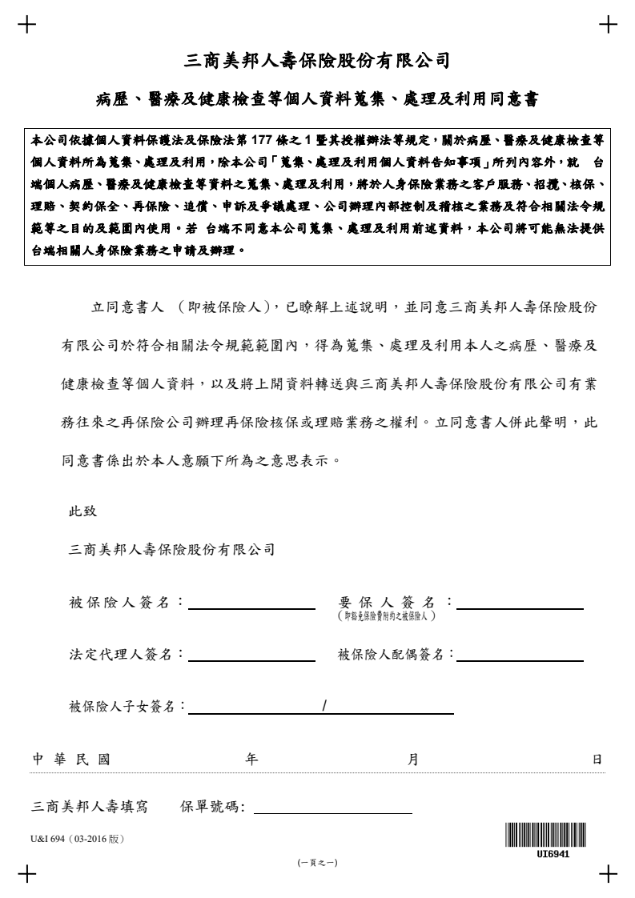

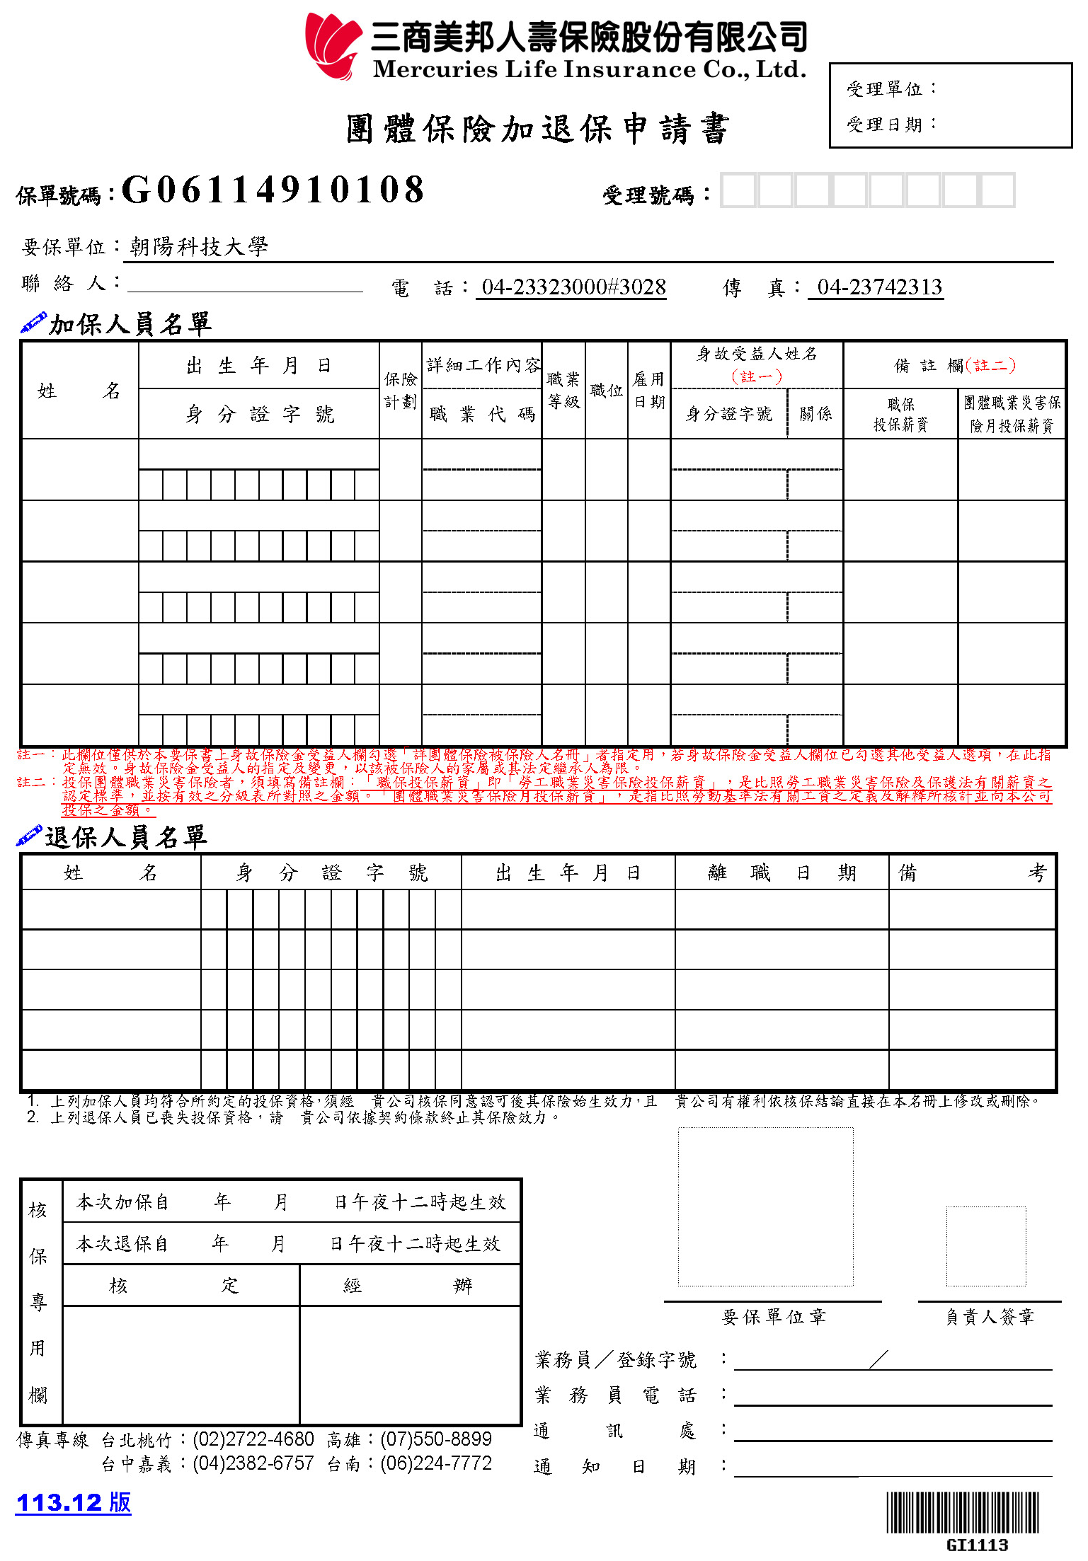
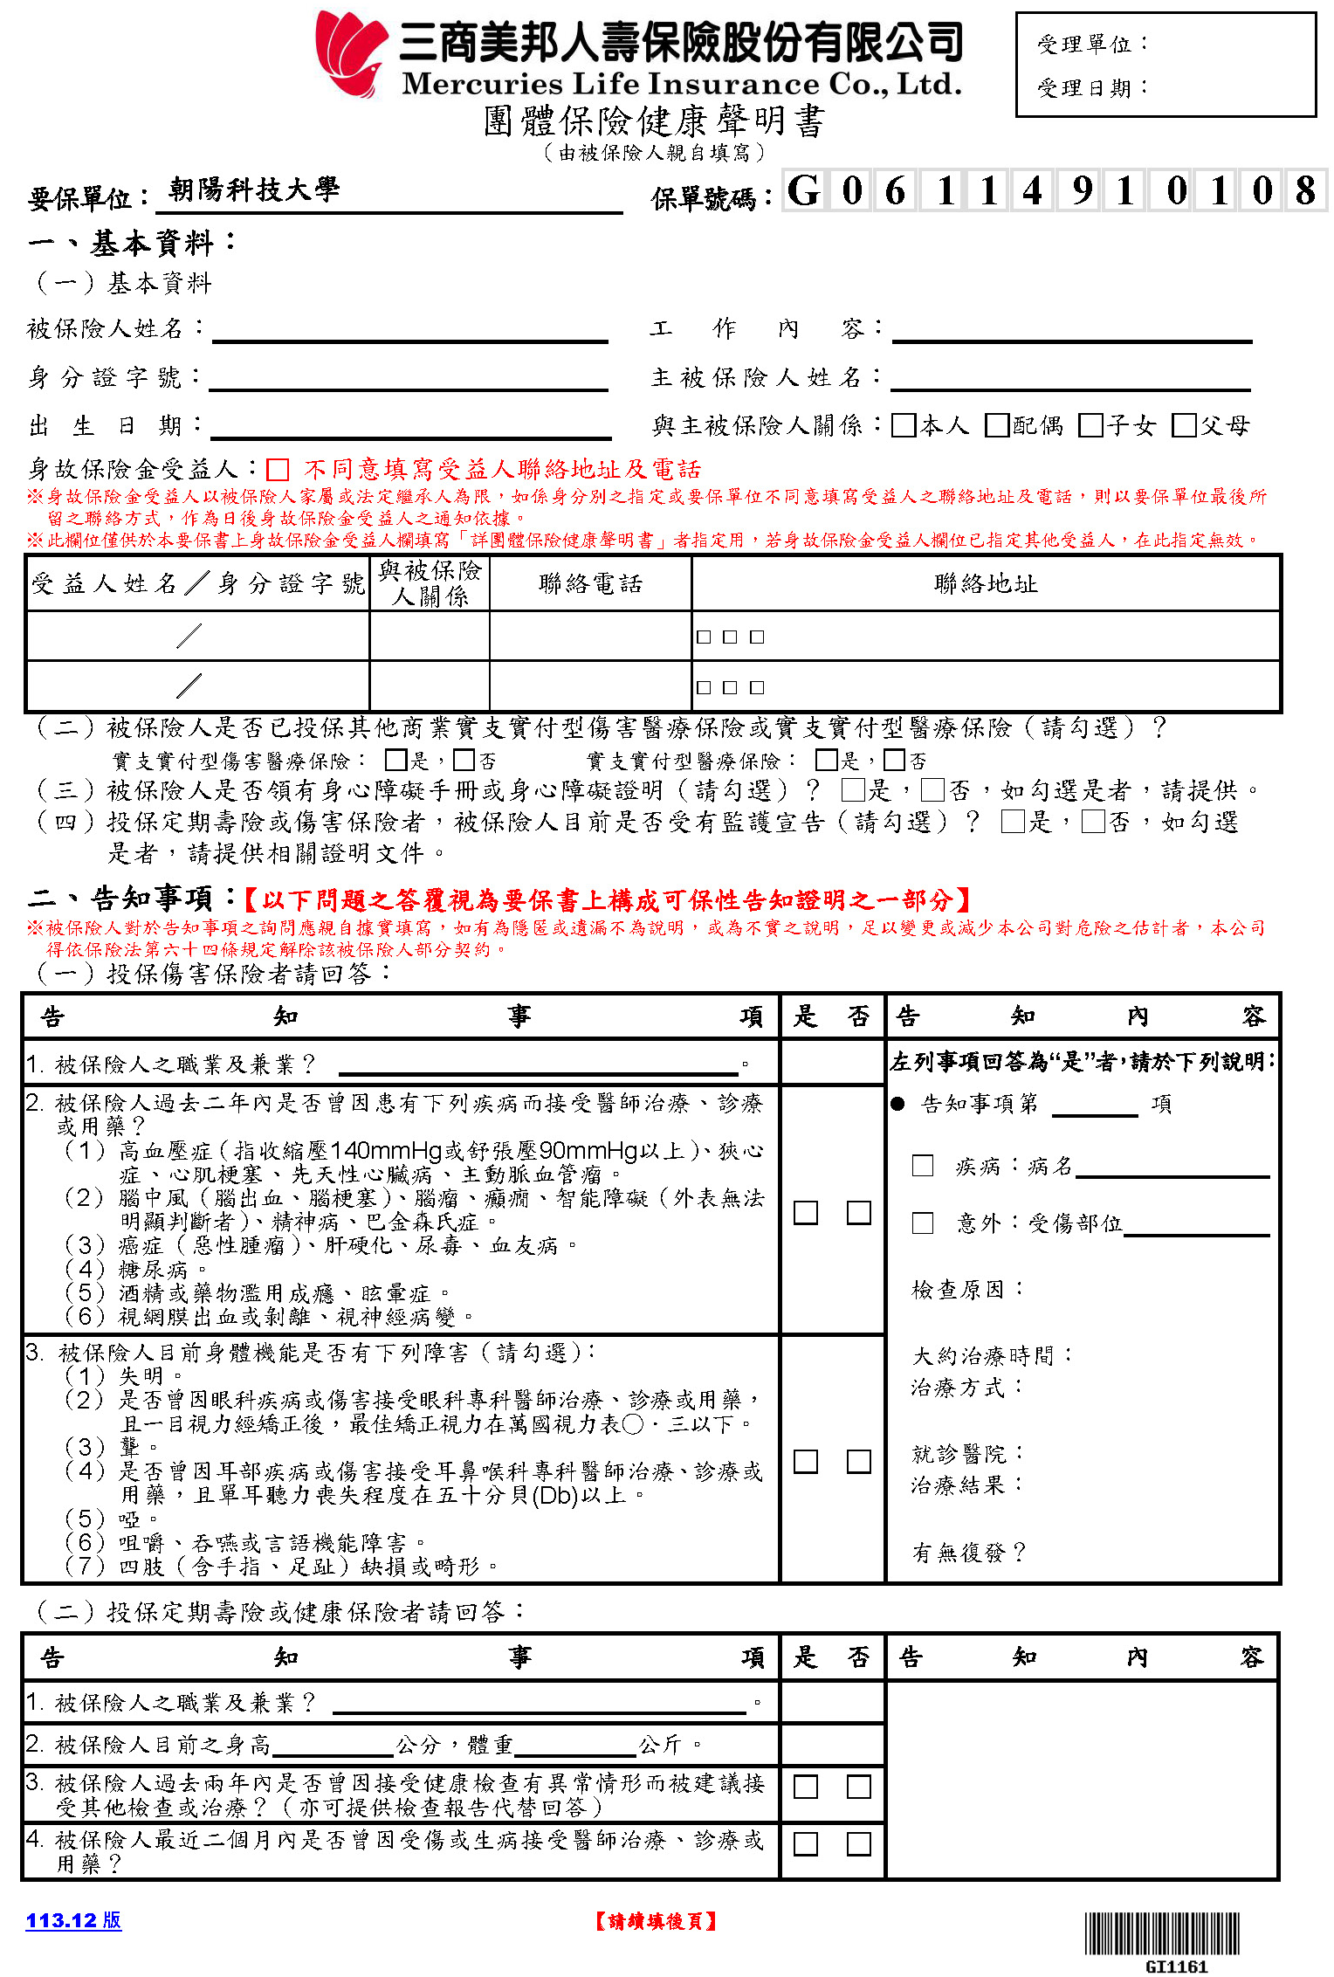
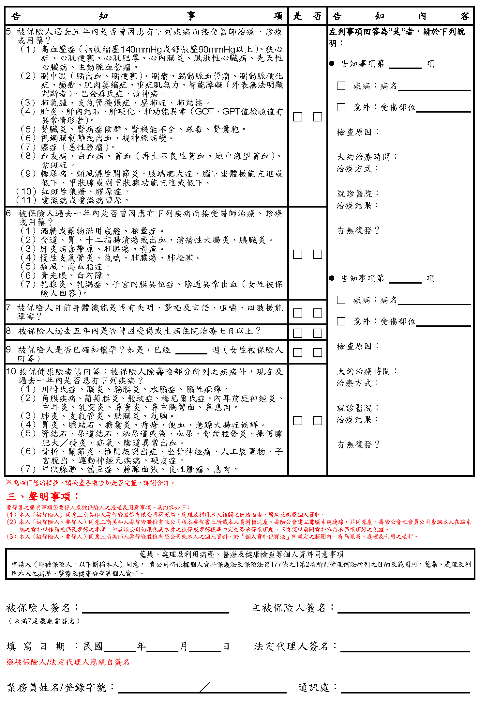
教職員工建立薪資帳戶
表件9
Salary Account Information
姓 名  Name |  | 人事代碼  Employee No.
銀行名稱  Name of Bank |  | 分行名稱  Branch name
帳 號
Account No.

『個人存摺封面影本』黏貼處
Please stick here the copy of your bankbook cover.
※合作金庫銀行為本校收付款配合銀行，入款帳戶非合作金庫銀行者，合作金庫銀行將自應付金額中扣取匯款手續費20元。
The financial institution which CYUT cooperated with is Taiwan Cooperative Bank. If your bank account is not Taiwan Cooperative Bank, remittance fee of NT$20 will be deducted from the amount remitted.
※可至全省合作金庫銀行辦理開戶或於合庫行員到校服務時間辦理(每星期二及星期五皆於下午1：00~ 2：00位於本校行政大樓一樓服務台)
You may open a new account at any branches of Taiwan Cooperative Bank, or you may approach the bank staff from 1 pm to 2 pm on every Tuesday and Friday at 1F of administration building.

本校依個人資料保護法第8條規定，於蒐集您的個人資料時告知下列事項：
According to Article 8 of Personal Data Protection Act (hereinafter “the Act”), Chaoyang University of Technology (hereinafter “CYUT”) notify you of the following when collecting your personal data:
朝陽科技大學為交付款項之目的(項目代號:129會計與相關服務)，須蒐集您個人的姓名、金融機構帳戶之號碼等個人資料(識別類:C001辨識個人者、C002識別財務者)，以在雙方合作關係存續期間及地區內進行匯款作業，如有欄位未填寫，則可能對匯款有所影響。如欲更改個人資料或行使其他個人資料保護法第3條的當事人權利，請洽本校出納組分機6061。
For the purpose of transferring payment (Code: 129 Accounting and related services), CYUT should collect your personal data, including your name and bank account number (category: identification C001, identifying finance C002). This is required for conducting money transfers during the duration of our cooperation within the specified region. Failure to complete all fields may impact the transfer. If you wish to update your personal data or exercise other rights under Article 3 of the Act, please contact the Bursary Section at ext. 6061.

朝陽科技大學( )學年度汽機車停車證申請表
表件10
Parking Permit Application Form
申請日期： 年 月 日
Date of Application: YYYY/MM/DD
姓名Name |  |  |  | 人事代碼Employee No.  (CYUT Faculty/Staff only)
單位Unit |  |  |  | 身份證字號（校外人士）  ID No./ARC No.
職稱Position | ■專任教職員Faculty/Staff
車輛種類  Transportation | □汽車Automobile  □機車Motorcycle |  |  | 牌照號碼  License plate No.
■新發First issue (補充免填說明：年度8/1起聘者，得於資訊系統開放期間8/1-8/15逕自登錄，若非開放時段者，則仍請填列本申請表。)
本校為蒐集新進人員個人基本資料，依個人資料保護法第8條規定向您告知下列事項：
According to Article 8 of Personal Data Protection Act (hereinafter“the Act”), Chaoyang University of Technology (hereinafter “CYUT”) notify you of the following statement and solicit your consent to use of your personal data by CYUT.
1蒐集之目的：為核發「教職員(汽)機車停車證」。Purpose of personal information collection:for the CYUT Parking Permit
2.蒐集個人資料之類別：識別類（C001）、執照或其他許可（C039）。Personal information gathered: Personal information supplied includes identification (C001)、License or other permission（C039）.
3.個人資料利用之期間、對象及地區：本校將於校務地區進行必要之業務聯繫；利用期間至您離職為止。
Utilizing period and region: Within Taiwan (including Penghu, Kinmen and Matsu, etc.), except the rules of the Act, CYUT may use the aforementioned information from now until CYUT operating existence.
4.個人資料利用方式：本校利用您的資料進行各項聯繫與校內車輛管理。
Users and methods of personal information utilization:For the aforementioned purposes of collection, CYUT will use your personal information for contact and notification if necessary.
5.個人資料之權利及權益：您得依個人資料保護法第3條，就您的個人資料行使請求查閱、補充、更正，及停止蒐集、處理、利用及請求刪除等權利，行使方式請洽本校游曉文(04-23323000 ext.6012)。
You reserve the right under Article 3 of the Act to request to inquiry, request a review, request copies, request to supply as well as correct the personal information, and request to stop collecting, processing, utilizing your personal information, and request to delete your personal information. CYUT may reject your request if there are any other rules of the Act.For the mode of exercise, please contact the Office of Human Resources of CYUT (Tel: 04-23323000#6012)
6.申請所需之個人資料個人資料，如有欄位未填寫，無法完成您的「教職員(汽)機車停車證」申請。
Please understand if you miss any information of the collection for your personal data, it may affect your relevant rights at CYUT. Thanks for your cooperation.
申請人Applicant |  |  | 申請單位主管Unit chief
 |  |  | 新進人員，依人事動態辦理，免核章。
經辦人Case officer |  | 事務組主任  Director of General Service Section |  |  | 總務長  Dean of General Affairs
說明：Instruction:
1、凡符合本校專(兼)任汽機車通行證申領規定者，填具本申請表向總務處事務組辦理。
Anyone who meets the school's full-time (part-time) automobile and motorcycle pass application requirements should fill in this application form and submit it to the General Affairs Office Affairs Team.
2、本通行證有效期限：自發證日起至證上所載有效日止。
Expiration: From issued date to expiry date on the pass.
3、依據92年5月5日本校「汽、機車管理及停車證發放協調會」決議，若有教職員替學生及工讀生代為申請停車證，經查獲者，除沒收該停車證之外，並送請人力資源處交由人評會審理。
Please do not apply for the Parking Permit for students or student assistants usage. If the situation happens, the Parking Permit will be confiscated and the applicant will be judged by the Personnel Evaluation Committee according to the resolution of CYUT vehicle management and Parking Permit Committee on May 5th, 2003.
4、請詳閱「朝陽科技大學校區車輛管制辦法」並依照規定使用。
Please follow the rules of CYUT campus vehicle management regulation.
通行證具領人:__________________ 日期： 年 月 日
Applicant signature: Date：YYYY / MM / DD
承辦單位：總務處事務組(行政大樓1Ｆ) 分機6012 General Section, Office of General Affairs (ext. 6012)
朝陽科技大學新進人員一般體格檢查通知
附件1
Attachment 1
Chaoyang University of Technology
Notice of General Physical Examination for New Joiners
為健全及落實本校健康管理與促進工作，並更進一步了解和照顧同仁之健康，依據職業安全衛生法第20條及勞工健康保護規則第14條規定，教職員工進入本校工作前需完成一般體格檢查，使能早期發現體格上之缺點並作進一步的治療，以維護及促進校園之健康。
For the improvement and implementation of health management and promotion initiatives of Chaoyang University of Technology (CYUT), and to ensure the well-being of colleagues, faculty and staff are required to undergo a general physical examination before reporting duty at CYUT in accordance with Article 20 of the Occupational Safety and Health Act and Article 14 of the Regulations of Labor Health Protection. This could help to identify physical weaknesses at earlier stage for prompt treatments and contribute to the maintenance and promotion of a healthy campus.

一、檢查單位：衛生福利部評鑑合格之勞工體格及健康檢查認可醫療機構，查詢網址https://hrpts.osha.gov.tw/asshp/hrpm1055.aspx
1.Units providing examination: Physical examination should be taken place in qualified medical units approved by the Ministry of Health and Welfare. Check this website for qualified units: https://hrpts.osha.gov.tw/asshp/hrpm1055.aspx
二、檢查項目：（下列項目皆須檢查，體檢報告有效期間為六個月內。）
2. Examination items: (All below listed items have to be examined, and the medical report is valid for 6 months.)
一般檢查  General Test | 作業檢查、既往病史、生活習慣及自覺症狀調查  身高、體重、腰圍、脈搏、血壓、視力、辨色力、聽力及身體各系統理學檢查  Survey on work experience, past medical history, living habit and subjective symptoms  Height, weight, waist circumference, pulse rate, blood pressure, eye-sight, color vision, hearing, oral and physical examination
尿液檢查  Urine Test | 尿蛋白、尿潛血  Urine Protein, Urine Occult Blood
Ｘ光檢查  X-Ray Examination | 胸部Ｘ光大片攝影檢查  Chest X-ray
血液檢查  Blood Test | 肝功能(SGPT)、肌酸酐(Cre)、總膽固醇(T-Chol)、三酸甘油脂(TG)、空腹血糖(AC Sugar)、高密度脂蛋白膽固醇(HDL-Cholesterol; HDL-C)、全血液常規(WBC、RBC、PLT、HCT、Hb、MCV)  Liver Function (SGPT), Creatinine, T-cholesterol, Triglyceride, AC Sugar, Uric Acid, HDL-Cholesterol, Complete Blood Count (WBC, RBC, PLT, HCT, Hb, MCV)
三、檢查結果：關心您自己的健康！如醫師評語有建議事項，請自行斟酌回健檢醫院家醫科門診或其他醫院(診所)門診。
3. Examination result: Do take care of your health. If there are recommendations from the physician, you may decide whether further follow up, either with the hospital/clinic where the check-up was taken place or with other hospitals/clinics, is needed.
四、注意事項：
1. 檢查當天請穿著舒適寬鬆衣服，需空腹至少8小時，檢查前一天請勿劇烈運動，以免影響檢驗結果。
2. 已配戴眼鏡者，檢查當天請務必攜帶，以便測量矯正後視力。
3. Ｘ光檢查：請穿著無鈕釦、無金屬配件之上衣，如有懷孕檢查前請先告知工作人員。
4. 尿液檢查：尿液檢體請截取中段尿，如遇生理期，檢查前請告知檢驗人員。
4. Items for attention:
4.1. On the day of examination, please wear comfortable and loose outfit and do not eat or drink at least 8 hours prior to the check-up (water however may be freely taken). Avoid heavy exercise the day before the check-up or else the examination result will be affected.
4.2. Those who use glasses or contact lens should bring them for measuring corrected eye-sight.
4.3. X-Ray: Wear plain upper outfit without metal accessories or buttons. If pregnant, please inform the staff prior to the test.
4.4. Urine Test: Collect a mid-stream urine sample. If you are menstruating, please inform the staff prior to the test.
五、繳交報告：
1. 請於到職日將紙本體檢報告正本繳至環境安全衛生處。(行政大樓1F A-102)健檢報告完成時間，依各醫院狀況而定，大約需一週，若需保留健檢資料請自行影印留存。
2. 若您有最近半年內之合格醫院體檢報告，且檢查項目皆符合本校規定，亦可於報到時繳交此紙本體檢報告無需再次體檢。
*若有任何體檢相關問題，請電洽環安處 (04)2332-3000 #6096或6097
5. Submission of report:
5.1. Please submit the printed original of your examination report to the Office of Environmental Safety and Health (located at Room A-102, 1F of Administration Building). Usually, it takes one week for the completion of report, but depends on different hospitals. You may keep a copy of the report if needed.
5.2. If you have an examination report issued by an approved hospital in recent 6 months and the required examination items are included, you can then submit this report by the time you report duty and do not have to do the examination again.
*For inquiry, please contact Office of Environmental Safety and Health at (04)2332-3000 ext. 6096 or 6097.

朝陽科技大學教職員電子郵件相關說明
附件2 Attachment 2
Chaoyang University of Technology
Email User Guide
重要說明 | 【電子郵件相關說明】Instruction  新進之教職員到職後預設建立t+人事代碼@cyut.edu.tw之Email位置，教職員可視需求另申請郵件別名。  New faculty and staff members will have their default email address set up as t+EmployeeNumber@cyut.edu.tw. Faculty and staff members may apply for additional email aliases based on their needs. Attachment 2  「朝陽科技大學教職員電子郵件別名申請表」Faculty Email Alias Application Form https://pmlis.cyut.edu.tw/form.php  - 電子郵件帳號 Account：t+人事代碼(Employee Number) (Example: t2019001)  - 電子郵件密碼 Password：同教職員資訊系統密碼（未於教職員資訊系統改密碼前預設密碼為身分證字號第１個字母大寫） The password is the same as the faculty information system password (before changing the password in the faculty information system, the default password is the uppercase first letter of the ID card).  - 電子郵件地址 Email Address：本校提供校內及Google Email信箱。The school provides both on-campus and Google email accounts.  3.1 校內個人郵件地址：t+人事代碼@cyut.edu.tw，例：t2019001@cyut.edu.tw。  On-campus personal email address: t+EmployeeNumber@cyut.edu.tw (e.g. t2019001@cyut.edu.tw)  3.2 申請郵件別名@cyut.edu.tw，例：dmlee@cyut.edu.tw。  Applying for email alias, the address will look like e.g. dmlee@cyut.edu.tw  3.3 以上郵件地址視為同一信箱位置及空間  The above email addresses are considered the same mailbox location and space.  3.4 Gmail郵件地址：帳號@gm.cyut.edu.tw 例：t2019001@gm.cyut.edu.tw。  Gmail Address: e.g. t2019001@gm.cyut.edu.tw  ※由於本校沒有Gmail郵件主機之實際管理權，故無法保證Gmail服務的穩定度及對於敏感性資訊的處理（如公務機密、個人隱私資料、健康資料、薪資及金融資料等），使用Gmail信箱與否，請個人自行考量。Due to the lack of actual management control over the Gmail email server at CYUT, we cannot guarantee the stability of the Gmail service or its handling of sensitive information (e.g. official secrets, personal privacy data, health information, salary, and financial data). The decision to use a Gmail mailbox or not is at the individual's discretion.  【收發信件設定】Email Sending and Receiving Configuration  本校郵件收發信設定: Settings for sending and receiving via school email  1.「Outlook收發」：內送(POP3)設為pop3.cyut.edu.tw。  外寄(SMTP)設為smtp.cyut.edu.tw(勾選【我的外寄伺服器需要驗證】)。  Outlook Sending and Receiving: Incoming (POP3): set as pop3.cyut.edu.tw; Outgoing (SMTP): set as smtp.cyut.edu.tw (check “My outgoing server (SMTP) requires authentication”)  2.「網頁收發」Webmail Sending and Receiving：https://webmail.cyut.edu.tw  Gmail郵件收發信: Gmail Email Sending and Receiving  可於教職員資訊系統內代登入，或使用Gmail網頁收發信：  You can log in via the faculty and staff information system or use Gmail webmail as follows:  1.前往https://gmail.com(若已登入其他帳號請記得登出)。  Go to https://gmail.com (if already logged into another account, please log out).  2.輸入帳號：如：hcchu@gm.cyut.edu.tw，密碼：教職員資訊系統密碼。  Enter the account: e.g. hcchu@gm.cyut.edu.tw, password: the faculty and staff information  system password.  3.若無法登入請試著至教職員資訊系統再改一次密碼(密碼更改將自動同步至Gmail)。  If unable to log in, try changing the password again in the faculty and staff information system (password changes will be automatically synchronized to Gmail).  ※詳細設定請參考圖書資訊處網頁→服務資源→技術手冊。  For detailed settings, please refer to the Technical Manual on the website of the Office of Poding Memorial Library and Information Services: https://pmlis.cyut.edu.tw/manual.php
承辦單位：圖資處 分機3092 Office of Poding Memorial Library and Information Services (ext. 3092)

